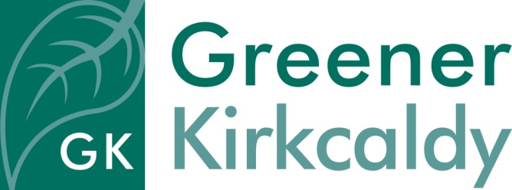
Job Description –
Energy Advisor

Responsible to Project Manager
Salary In the range of £25,749-£26,749 + 6% contribution to pension scheme (pro rata)
Hours of work 35 hours per week, Monday – Friday, also to include the occasional Saturday and evening work.
Place of work Greener Kirkcaldy’s base at 8 East Fergus Place, Kirkcaldy; community locations and people’s homes throughout Mid and West Fife. Greener Kirkcaldy has a hybrid working policy, allowing staff to work from a hybrid of office and home depending on the needs of each role.
Contract Permanent after completion of 3-month probation
Holiday 33 days, inclusive of public holidays, per annum pro rata
Requirements The post-holder will be subject to a Disclosure Scotland check
Job purpose
Greener Kirkcaldy is a community-led charity, working on a local scale to benefit people and our environment. We are concerned about climate change and by the impact of rising food and fuel costs. We would like to see a future where everyone is able to heat their home affordably, eat well, and tread more lightly on our planet.

We lead the ‘Cosy Kingdom’ partnership of organisations who deliver energy and fuel poverty advice services for householders across Fife – including community engagement on energy efficiency and micro-renewables and advice on tariffs and switching. The service helps people stay warm while spending a lower proportion of their income on fuel and develops skills and confidence for participants to take more control of their energy use and bills.

Our team of Energy Advisors deliver energy advice work in Mid and West Fife, making home energy advice visits, delivering talks and workshops on saving energy and attending events to raise the profile of the service.
Specific responsibilities
- To carry out home advice visits offering one-to-one advice, support and information to householders.
- Provide telephone advice.
- To deliver events, advice surgeries, workshops and talks for community groups and the wider public.
- To attend local events to promote the project.
- To work with the project team to develop activities and resources to raise awareness of home energy use, and to change attitudes and behaviours.
- To engage a wide range of people in the project.
- To assist in the development and implementation of monitoring and evaluation systems, and carry out follow-up surveys of project participants.
- To assist with the completion of project reporting.
- To develop a network of contacts, including local community groups, for the project to work with.

General responsibilities
- To work as part of the Greener Kirkcaldy team to promote and encourage understanding of environmental issues and fuel poverty.
- To promote the values of Greener Kirkcaldy when working in the local community.
- To engage with members of the public in a positive and constructive way and ensure their needs are met.
- To provide excellent customer service.
- To communicate effectively with the team.
- To report on the success of allocated tasks, both verbally and in writing.
- To work effectively with other team members (staff and volunteers) to achieve goals.
- To work constructively with project partners.
- To report on the success of allocated tasks.
- To comply fully with the organisation ethos, policies and procedures and relevant legislation.
- To attend and contribute to team meetings and training courses.
- To undertake other duties in line with the job purpose.

