Big Dream Green Holiday Competition Entry Form
Who is entering the competition?
Name:

Age:

Parental consent and contact details. This must be filled in by an adult:
Name of parent/guardian/teacher:

Relationship to entrant:

School/Organisation (if applicable):

Council area:

Adult’s contact information
(for if you win!):

Email:

Tel:

Declaration: I give permission for (name) to enter the competition:

Signed: Date
Please check this box if you would like to sign up to Greener Kirkcaldy’s e-newsletter? ☐

Send to:
Send your entries via email to info@greenerkirkcaldy.org.uk
Please include Big Green Dream Holiday competition in the subject line of the email.
Or post to:
Big Green Dream Holiday Competition, Greener Kirkcaldy, 8 East Fergus Place, Kirkcaldy, KY1 1XT
Get your entries to us by the end of the day Monday 28th February 2022.
Competition is open to all children aged 10 -14.
Your personal information will be used solely for the purposes of the Big Green Dream Holiday competition and will not be shared with third parties. See Greener Kirkcaldy’s full privacy notice.
Thanks for taking part and good luck!

Where will you stay?

Where will you go and how will you get there? Why did you chose this place?

My Big Green Dream Holiday Entry Form by Name: Remember you can write, draw or share photos, videos and links.

What activities will you do on your dream holiday?

How else could you make this trip more environmentally friendly? Why do you think it is important to make more environmentally-friendly choices?

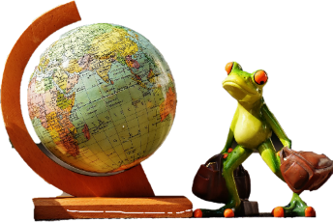
Competition Guidance and Information
This page gives you some ideas about what you could include in your entry. Use the information and links help you design your dream green holiday and fill in the entry form on the previous page. If you need extra space, please continue on a blank page.
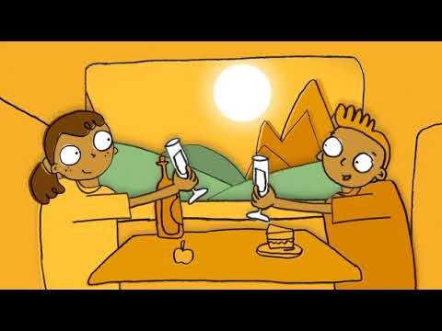
Where will you go and how will you get there? Why did you choose this place?
Remember that going further could mean using more polluting fuel than staying closer to home. Think about all the different ways you can travel - plane, bike, hot air-balloon or horse! Remember- some modes of transport release more global warming greenhouse gases then others. Watch this video to give you some ideas: https://flightfree.co.uk/why_flight_free/

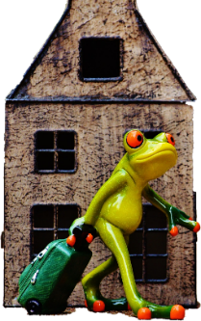
Where will you stay?
Will you choose a fancy green hotel, get close to nature, camp under the stars or is a yurt more your style? Remember to make sure your choice is as eco-friendly as possible! These websites might spark a few ideas
https://www.lonelyplanet.com/articles/how-to-go-green-when-you-travel https://wwf.panda.org/act/live_green/travel/on_vacation/
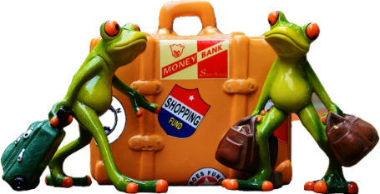

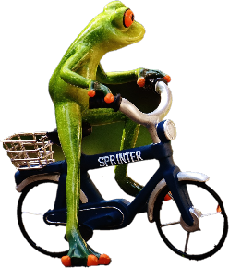

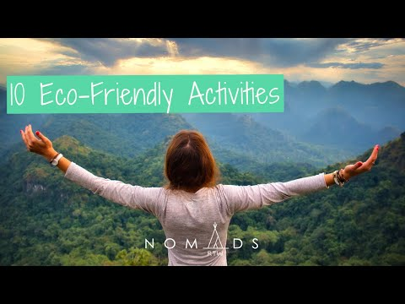
What activities will you do on your dream holiday?
Are there any environmentally friendly activities you want to try? Whether it's a hike in nature, fun on the beach or even a litter pick - there are loads of options that are climate conscious. This video will give you some ideas. Check out these website too: https://www.lifegate.com/holidays-with-kids https://www.nomadsrtw.com/experiences/eco-friendly-activities/

What else? How else could you make this trip more environmentally friendly? Why do you think it is important to make more environmentally friendly choices?
This is your chance to show off your eco-knowhow and really make your entry stand out. https://ecofriendlykids.co.uk/ecofriendlyfamilyholidays/

