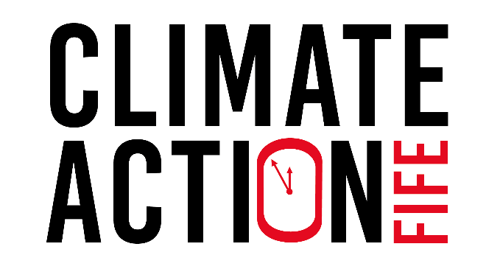

  - Climate Action Fife Small Grants Fund

What is it?
Are you a Fife community organisation? Do you want to engage your community in action on the climate emergency?
Climate Action Fife brings together individuals, communities, local government and businesses. The Fife-wide partnership project aims to tackle the climate emergency. And make Fife a greener and fairer place to live.
The Climate Action Fife Small Grants Fund is open to any Fife community organisation. Local community groups can apply for a grant of up to £500 to trial activities. The process is simple and quick.
This is the second round of funding. The first cohort of funded community groups delivered projects in Summer 2021.
Climate Action Fife is a partnership between Greener Kirkcaldy, Fife Council, Fife College and Fife Communities Climate Action Network. It is funded by the National Lottery Community Fund’s new Climate Action Fund.

How does it work?
Applying for funding is simple, and we’ll get back to you quickly.
If you are successful you will receive the funds up front and the reporting requirements are straight-forward.
To apply: complete and return this application form to admin@greenerkirkcaldy.org.uk
Do not hesitate to contact us to request this form in Large Print or other formats.
The deadline is Tuesday 14 September 5pm. Attach a copy of your organisation’s constitution, too.
You’ll hear back from us within 1 weeks of the deadline, telling you if your application was successful.

Projects can begin or start from 11th October 2021 and be complete by 28th November 2021. Please note that a condition of the award will be submission of a short end of project report. We ask you to share your learning from the project and (where appropriate) photos and a case study.

Who can apply?
Local community groups or organisations based in, and working in, Fife. We accept applications from constituted, non-profit-distributing organisations. We’re looking for applications from grassroots organisations which are community-led.

What can I apply for?
Your project should trial an activity to engage your community in the climate emergency.
Aim activities at audiences not already engaged in the climate agenda. You want to increase knowledge and awareness around the climate emergency. And increase skills and confidence to take climate action.
You could run climate-themed film showings. ‘climate conversation’ discussion groups, or led walks with a climate-change theme.
We will use project findings for Climate Action Fife’s climate change engagement toolkit. It will include a resource library of tried and tested climate change engagement activities.
The grant can cover staff costs, volunteer expenses, event materials, room hire and marketing.
We cannot fund political or religious activities, or the buying of alcohol. See Appendix 1 for a full list of what we cannot fund.

Who’s behind this?
Climate Action Fife is funded by The National Lottery Community Fund’s Climate Action Fund. The fund aims to enable people and communities to take the lead in tackling the climate emergency by building a network of people and communities, well-placed to drive change, between and beyond their community.
The National Lottery Community Fund is the largest funder of community activity in the UK. They award money raised by National Lottery players to communities across England, Scotland, Wales and Northern Ireland.
Since June 2004, they have made over 200,000 grants and awarded over £9 billion to projects that have benefited millions of people. Website: https://www.tnlcommunityfund.org.uk/

Application Form
The deadline for receipt of applications is 5pm, Tuesday 14 September, 2021
If you have any questions contact Dianne Girvan by on admin@greenerkirkcaldy.org.uk
Your organisation and contact details
Name of organisation
Type of organisation
Address
Contact name
Telephone number
Email address
Organisation website
Organisation social media links

Tell us about your organisation. We only accept applicants from constituted, non-profit-distributing organisations, based in Fife. (Max 200 words)
Tell us about your community. Where will the project take place? Who is your target audience? (Max 200 words)

Tell us about your project. What will you do? What impact will the project have? Why is it needed? (Max 400 words)

When will you deliver the project? Tell us your expected start and end dates.
All projects must take place between 11th October and 28th November 2021.
What will the project cost? Tell us how you will spend the money you are requesting from the Climate Action Fife Small Grants Fund. Note: The largest grant is £500, inclusive of any VAT.

Appendix 1: What we cannot fund
Climate Action Fife is funded by The National Lottery Community Fund. In line with their terms and conditions, we cannot fund:
- statutory activities and activities that replace government funding
(For example, we can only fund school activities that happen outside of normal teaching hours)
- loans, endowments or interest
- paying someone else to write your application
- political activities, including lobbying
- activities where a profit will be distributed for private gain
- VAT you can reclaim
- Alcohol
- things you’ve spent money on in the past and are looking to claim for now
- items which will only benefit an individual, rather than the wider community
- religious activities
(We can fund religious organisations if their project benefits the wider community. And does not include religious content).

