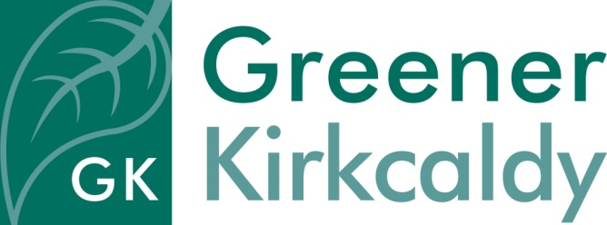

Role Description – Community Food Team Sessional Worker
Responsible to Community Food Team Project Manager
Rate of pay £16.08 per hour on a self- employed basis
Hours of work As required, usually 16 hours per week including Wednesdays and Thursdays
Place of work 8 East Fergus Place, Kirkcaldy
Requirement A Disclosure check is required for this post
Contract Until March 2022
About us

Greener Kirkcaldy is a community-led charity and development trust working on a local scale to benefit people and our environment. Our main base is at 8 East Fergus Place, Kirkcaldy, where The Lang Spoon Community Kitchen is also located.

The Lang Spoon Community Kitchen includes two kitchens:

- The Lang Spoon Training Kitchen: where people come to take part in cookery courses and workshops
- The Lang Spoon Production Kitchen: commercial kitchen for catering events in our events space, or for food producers to hire

The Lang Toun Larder is a community food pantry. We collect and redistribute surplus and unsold food from businesses, keeping good food in circulation and reducing food waste.

The training kitchen is a fully equipped modern kitchen with 8 work stations. We offer courses and workshops on a large range of world cuisines and cooking skills such as bread making, baking, and lots more. We also offer training, volunteer and work experience opportunities, community meals and engagement with our community on healthy, sustainable food. The Dignity Principles are embedded in all our food work.

We minimise food waste and use produce that is local, seasonal and fresh.

We are recruiting for a Community Food Team sessional worker to support our work.

Role purpose

This is an exciting opportunity to join the Community Food Team to support our busy weekly programmes and activities. We are looking for a sessional worker with experience of working in a community setting, food preparation and cooking skills, as well as helping to train others, assisting group activities, developing partner relationships, maintaining a busy kitchen to a high hygienic standard and supporting people and volunteers to develop. Our busiest days are Wednesdays and Thursdays so you will need to be available on both those days as well other times to be agreed in advance, which may include some evening work.

We are looking for someone with a passion for connecting food and people, a willingness to get stuck in, and the ability to adapt to a busy work schedule.
Specific responsibilities
- Support the team to develop and deliver a range of community food activities, cooking classes, volunteer and training sessions and a community pantry.
- Encourage and support participants and volunteers who are involved in our programmes.
- Assist the team to manage, coordinate and collect deliveries and donations and support stock control.
- Assist the team to ensure kitchens and other food areas are maintained to a high standard and comply with Environmental Health.
- Ensure the safety of all participants and volunteers.
- Assist with monitoring and evaluation systems.
General responsibilities
- Engage with volunteers and members of the public in a positive and constructive way and ensure their needs are met.
- Take an inclusive and empowering ‘community development’ approach.
- Communicate effectively with others.
- Work with team members to achieve goals.
- Work constructively with project partners.
- Report on the success of allocated tasks.
- Comply fully with the organisation ethos, policies and procedures and relevant legislation.
- Attend project meetings as required.
- Undertake other duties in line with the role purpose.

Person Specification

Knowledge | Essential | Desirable
REHIS Elementary Certificate in Food Hygiene
An understanding or experience of HACCP control systems
A basic knowledge of food and food groups
An understanding of the climate emergency and reducing food waste
Skills and abilities
Experience of food prep and cooking in a professional or community / training setting
Supporting or working with people/ volunteers from a range of backgrounds
A full driving licence would be an advantage for this role but is not essential.

Using own initiative and taking responsibility for specific tasks
Able to communicate verbally and in writing
IT skills
Personal qualities
Reliable, trustworthy and honest
Non-judgemental and non-discriminatory

