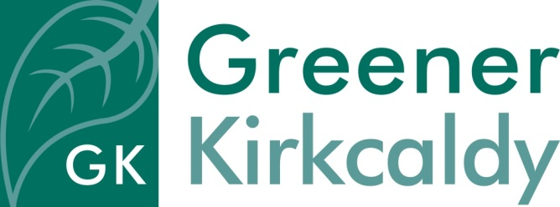
Person Specification – Admin Assistant (Maternity Cover)

Essential

- Previous experience in reception duties
- Good communication skills using a variety of methods (such as written, spoken, email)
- Good computer skills and the proven ability to use a range of packages
- Experience of balancing and prioritising a varied workload
- Flexibility and the ability to adapt according to the needs of the project
- Initiative and self-motivation to complete tasks
- Excellent attention to detail
- Commitment to quality and high standards of customer care
- A positive and enthusiastic attitude
- A commitment to being environmentally friendly

Desirable

- A relevant qualification
- Experience of working in a voluntary organisation
- Willingness to participate in training provided by Greener Kirkcaldy

