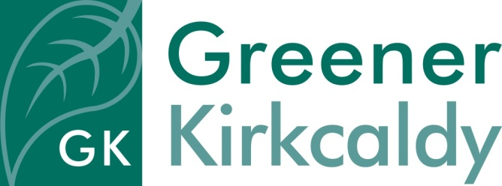
Job Description Admin Assistant (Maternity Cover)

Responsible to Office Manager
Salary £19,431 pro rata
Hours of work Full time with occasional attendance at evening or weekend events
Place of work Greener Kirkcaldy’s base at 8 East Fergus Place, KIRKCALDY
Contract Fixed contract to 24th June 2022
Holiday 33 days holiday including 5 days public holiday per annum pro rata
Requirements The post-holder will be subject to a Disclosure Scotland check

Job purpose
You will be responsible for being the first point of contact for those coming into our community building and answering the general enquiries over the telephone. You will also provide administrative assistance to all staff within Greener Kirkcaldy. You will be working in a friendly, dynamic front of house setting and should enjoy completing a range of administrative tasks along with welcoming guests into the building.

Specific responsibilities

- To work as part of Greener Kirkcaldy’s ‘Front of House’ team:

- Maintain a welcoming, informative, clean and tidy space for visitors
- Act as a first point of contact for members of the public
- Offer information and sign-post to Greener Kirkcaldy’s and others’ services
- Provide excellent customer service, engaging with members of the public in a positive and constructive way and ensure their needs are met

- Check all first aid boxes and replenish if necessary
- Deal with telephone and email enquiries from the general public, statutory and voluntary agencies
- Keep the community fridge topped up and accept food donations from the public
- Collect information and update databases
- Support the organisation to keep paperwork up to date, and to adhere to Greener Kirkcaldy’s quality management systems
- Provide basic IT support to the team
- Assist with the arrangement of events, meetings and room hire
- Record and distribute post
- Cash handling
- Minute taking

General responsibilities

- To work as part of the Greener Kirkcaldy team to promote and encourage understanding of environmental issues in the local area
- To comply fully with the organisation’s ethos, policies and procedures and relevant legislation
- To ensure the building is run in an environmentally friendly way
- To assist all teams with general administration
- To undertake other duties in line with the job purpose

