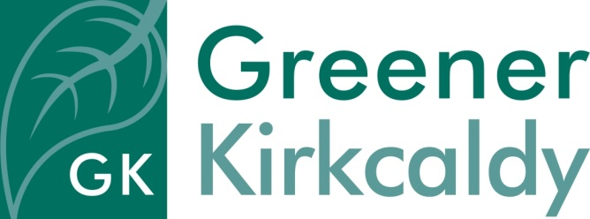
Job Description – Cosy Kingdom Admin Assistant

Responsible to Office Manager
Salary £18,525 pro rata
Hours of work 21 hours on a flexible basis, including some evenings
and occasional Saturday work*

Place of work Greener Kirkcaldy project office (once Covid guidance allows – until then, working from home)
Contract Fixed term to 31st March 2022 initially, with possibility of extension
Holiday 33 days, inclusive of public holidays, per annum, pro rata

Job purpose
You will be responsible for providing admin assistance to the Cosy Kingdom
Project, which helps households in Fife keep warm and save money, by giving
tailored home energy advice.

The team consists of a Project Manager, 6 x Energy Advisors, and an Administrator.

Your role will be to work alongside the Administrator to ensure comprehensive service delivery.

Specific responsibilities

- Maintaining and setting up filing systems
- Dealing with telephone and email enquiries from the general public, statutory and voluntary agencies
- Taking, and distributing, team meeting minutes
- Booking home energy advice visits via telephone, email, FORT database and face to face (when current Covid guidelines allow)
- Populating the Energy Advisors calendars
- Collecting information and updating databases
- Supporting the team to keep paperwork up to date, and to adhere to Greener Kirkcaldy’s quality management systems
- Providing basic IT support to the team
- Assisting with the arrangement of events and meetings

General responsibilities

- To work as part of the Greener Kirkcaldy team to promote and encourage understanding of environmental issues in the local area
- To comply fully with the organisation’s ethos, policies and procedures and relevant legislation
- To ensure the office is run in an environmentally friendly way
- To undertake other duties in line with the job purpose

* Greener Kirkcaldy operates a 'time off in lieu' policy for any work outwith office hours.

